

Functional Test Report for INJI Web v0.16.0

07 March 2026

Document History
It outlines the strategy used to ensure a comprehensive evaluation.

Version | Author | Date | Review | Affected Sections
V1.0 | Mrudula | 7/3/2026 | - Chaitanya Kesiraju  - Ragini Krishna | New Document

Contents

Introduction 4
Overview and Scope 4
Test Approach 4
Test Organization 5
Test Planning 5
Browser Versions 5
Test Environment 5
Test Execution Report 6
Test case execution summary 6
Automation INJI Web UI 6
Automation INJI Web API Mimoto 7
Defect Metrics 7
Defect Metrics for the Release 0.16.0 7
Known Issues Metrics 7
Conclusion 8
QA Approval 8
Appendix 9
Appendix A: Versions 9

Introduction
The scope of testing is to verify fitment to the specification from the perspective of Functionality, Configurability and Customizability. Verification is performed not only from the end-user perspective but also from the System Integrator (SI) point of view. Hence, the Configurability and Extensibility of the software are also assessed. This ensures the readiness of the software for use in multiple countries and diverse identity ecosystems.

Overview and Scope
- Inji Home page
- Issuer and Credential selection
- Authenticating with user credentials
- PDF Generation and Auto download
- Retrieve Issuers and Credential list
- Downloading VC
- Multi languages support
- Error Handling
- Issuers support
- QR Code
- Durian data storage integration
- Login with Google and Passcode
- OpenID4VP Implementation
- Secure Time Bound Storage
- Locale Support
- Authorization endpoint discovery through auth server well-known
- Sd jwt support
- SVG Support
- Claim 169

Test Approach
The Functional verification of the Inji Web application is performed on Windows, Android and iOS platforms to ensure alignment with product specifications and business requirements. Analyzed with respect to functional stability, data integrity, and UI consistency. The validation adopts a persona-based testing strategy, simulating real-world user scenarios across diverse device matrices and multi-language configurations to ensure robustness in both online and offline environments.
☐ Functionality
☐ API & UI Automation
☐ Configurability
☐ Customizability

Test Organization
Table 1: Test Organization
Name | Functional Role | Responsibilities
Mrudula | QA Engineer | Verifying the functionality, stability of the application,and report preparation.
Chaitanya K | QA Manager | Overviewing the test execution and review of the report.
Ragini Krishna | Senior QA Manager | High-level governance and executive reviews of reports and execution.

Test Planning
- Data Readiness: Validate the availability of all services along with configured identity schemas (UIN/VID) to support biometric and authentication flows.
- Coverage Distribution: Execute test scenarios across a broad matrix of browsers on Windows and Mac system spanning multiple user personas to ensure end-to-end compatibility covers

Browser Versions
Used the below browser versions in testing INJI WEB
- Chrome: Version 145.0.7632.160
- Firefox: Version 148.0 (64-bit)
- Edge: Version 145.0.3800.82
- Safari : Version 17

Test Environment
Table 2: Test Environment
Images (qa-inji1 env)
INJI Web - Injistackqa/ui-test:0.16.x
Injistackqa/inji-web:0.16.x
Injistackqa/apitest-mimoto:0.21.x
Injistackqa/mimoto:0.21.x

Test Execution Report

Test case execution summary
Table 3: Test Execution Summary
Platform | Total | Pass | Fail | Skip
INJI WEB | 1125 | 1036 | 89 | 0
Test Rate: 100% With Pass Rate: 93%

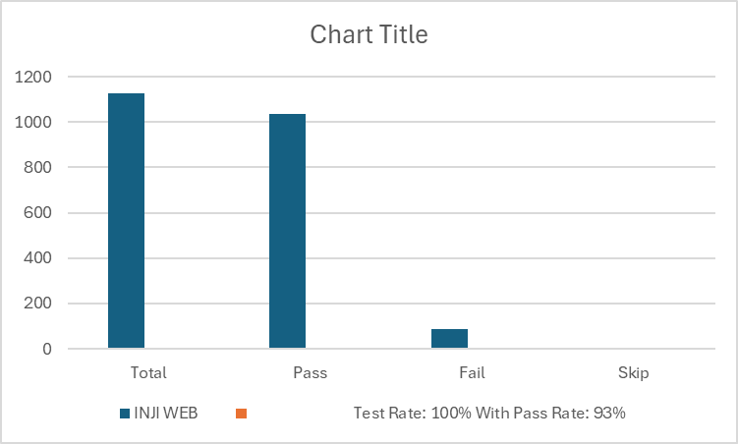

Automation INJI Web UI
Table 4: UI Automation
Total | Pass | Fail | Known Issues | Ignored
28 | 28 | 0 | 0 | 0
Test Rate: 100% With Pass Rate: 100%

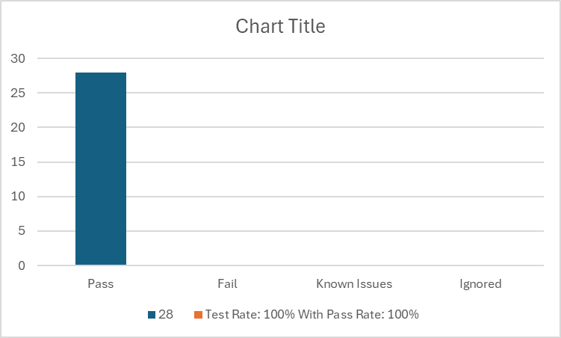

Automation INJI Web API Mimoto
Table 5: API Automation Result

Total | Pass | Fail | Known Issues | Ignored
349 | 312 | 0 | 4 | 33
Test Rate: 100% With Pass Rate: 100%

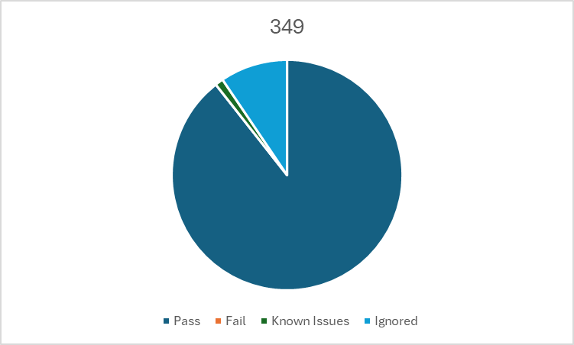

Defect Metrics

Defect Metrics for the Release 0.16.0
The following table depicts only the bugs which are found and not addressed in the current release.
Table 6: Defect Metrics for the Release
Blocker | Critical | Major | Minor | Total
0 | 0 | 1 | 5 | 6

Known Issues Metrics
This section focuses on a separate category of issues that are known but not addressed in the current release. It provides a count and severity distribution for these defects across releases.
Table 7: Defect Metrics for the known issues
Blocker | Critical | Major | Minor | Total
0 | 0 | 54 | 28 | 82

Conclusion
This section summarizes the key findings of test execution. It also provides a final QA recommendation on the build's readiness for release. The functional verification for Inji-web version 0.16.0 has been successfully completed. The testing cycle achieved a 100% execution rate with a 92% pass rate across a total of 1125 test cases. Additionally, API automation achieved a 100% pass rate.
While there are 6 open defects (0 Critical, 1 Major, 5 Minor) and 82 known issues in total, there are zero blocker defects identified. The application has demonstrated functional stability and data integrity consistent with product specifications.

QA Approval
The build has successfully met the defined exit criteria and is recommended for release. The approval is based on the following satisfied conditions:
- Test Case Execution Completion: 100% of planned scenarios executed.
- Defect Status: No Blocker defects remain open.
- Documentation Sign-off: All test artifacts and reports are finalized.
- Test Environment Stability: The test environment remained stable throughout the execution cycle.

Table 8: Report is signed off details
Name | Functional Role | Responsibilities
Chaitanya K | QA Manager
Ragini Krishna | Senior QA Manager

Appendix
This includes additional reference information for the report. It contains a history of document versions and a list of acronyms and their meanings.

Appendix A: Versions
 | Date | Author | Reviewers
V1.0 | 10/12/2025 | Santosh | Chaitanya K  Ragini Krishna

END OF DOCUMENT

